Volume 17, Edition no. 2 – April 2017
ISSN: 2471-870X
JOURNAL OF FUNERAL SERVICE EDUCATION

Contents

Evaluating Crematory Emissions: A Grassroots Exploratory Study
John B. Fritch, Gary Steward, Jr, John Bowen, Morgan Black, Garrett Dressler, Jonathan Pope, Bethany Harman, Allison Arnold, Cierra Allen, Johnnie Bennett, Megan Brown, Haley Harris, Devon Legaard, Jay Ross & Tye Chapman………………….4

Emotional Intelligence Ability as a Possible Motivating: Characteristic of First-Generation Mortuary Science Students
Cody L. Lopasky and Rick Harrington…………………………………….22

INFORMATION FOR AUTHORS

The Journal of Funeral Service Education is a peer reviewed journal dedicated to the dissemination of theoretical, pedagogical, empirical, historical, and the holistic nature of funeral service education and practice. This Journal exists to serve the needs of funeral service educators.

Manuscripts of all lengths will be considered, from brief notes to monographs. Brief notes on methodology, instrumentation, or a replication study will be considered for publication. A manuscript is accepted for review with the understanding that no substantial portion of the manuscript has been published or is under consideration for publication elsewhere and that its submission for publication has been approved by all the authors and by the institution where the work was carried out and is free of copyright restrictions. Any person cited as a source of personal communications has approved such citation. Written authorization may be required at the editors’ discretion. Articles and any other materials published in the Journal of Funeral Service Education represent the opinions of the author(s) and should not be construed to reflect the opinions of the editor(s) or the publisher. Manuscripts that do not meet the general criteria or standards for publication in the Journal of Funeral Service Education will be immediately returned to the author(s), without detailed review. Upon acceptance of an article, the manuscript becomes property of the Journal of Funeral Service Education.

Preparation of Manuscript
Authors should follow the instructions given in the sixth edition of the Publication Manual of the American Psychological Association. Manuscripts that do not adhere to these guidelines may be returned without benefit of editorial review. Manuscripts should be double-spaced throughout. Pages should be numbered consecutively and organized as follows:
The title page (p. 1) should contain the article title, authors' names and complete affiliations, and the address for manuscript correspondence (including e-mail address, telephone and fax numbers). Authors should not place their names on the manuscript itself.
The abstract (p. 2) must be a single paragraph that summarizes the main findings of the paper in less than 150 words.
References should be cited in the text by author's surname and the year of publication, e.g., Holland (1985); Super et al. (1963); Lofquist and Dawis (1984, p. 224) for references to a specific page. If a reference has more than two authors, the citation includes the surnames of all authors at the first mention, but later citations of the same reference include only the surname of the first author and the abbreviation "et al." Suffixes should be used following the date to distinguish two or more works by the same author(s) in the same year (e.g., Roe, 1979a, 1979b). Literature citations in the bibliography should be typed double-spaced and arranged alphabetically according to the surname of the author. Journal titles should be written out in full rather than abbreviated. Only articles that have been published or are in press should be included in the references. Unpublished results or personal communications should be cited as such in the text.
The author(s) is responsible for obtaining permission to reproduce copyrighted material from other sources and are required to sign an agreement for the transfer of copyright to the University Mortuary Science Education Association. The author (s) of each accepted manuscript will receive one complete copy of the issue in which their contribution appears.

Submission of Manuscript:

An electronic format containing the manuscript in Word format should be submitted to:

Journal of Funeral Service Education
C/O Anthony Fleege
Mortuary Science and Funeral Service Program
Mailcode 6615
Southern Illinois University Carbondale
Carbondale, IL 62901-6615

Or

E-Mail the manuscript in Word format to:
Anthony Fleege—E-mail splash@siu.edu

Immediate notification will be sent to the author upon receipt and allow 6-8 weeks for notification of manuscript status.

Evaluating Crematory Emissions: A Grassroots Exploratory Study
John B. Fritch, Gary Steward, Jr, John Bowen, Morgan Black, Garrett Dressler, Jonathan Pope, Bethany Harman, Allison Arnold, Cierra Allen, Johnnie Bennett, Megan Brown, Haley Harris, Devon Legaard, Jay Ross & Tye Chapman
University of Central Oklahoma

Address all correspondence to: John B. Fritch, Ph.D.
Funeral Service Department
Coyner Health Sciences Building, 156
University of Central Oklahoma
Edmond, Oklahoma 73034
Ph. (405) 974-5195
Fax. (405) 974-3848
jfritch@uco.edu

Abstract
This exploratory study sought to determine emissions that result from the cremation process. The study collected and analyzed emissions (N=2) from two cremations conducted from the same crematory. To extract organics, an Agilent 7890A Gas Chromatograph-Mass Spectrometer was used in conjunction with an Agilent 5975C quadrupole mass spectrometer with a triple axis detector, and an Agilent 30m x 0.25 mm x 0.50 µm HP-5ms non-polar capillary column was used for analysis. Compounds were detected from the sample and extracted from a polyurethane foam filter used during sample collection. These compounds were determined solely by mass spectra library matches. The spectra were matched by the computer software by comparing the mass peak heights of the compounds detected to the mass spectra contained in the NIST library. Therefore, the higher the match quality, the greater the probability that matched compound is the true identity. Dioxin-like molecules were identified, but in unknown concentrations.

Evaluating Crematory Emissions: A Grassroots Exploratory Study
Introduction
There has been considerable controversy over the past ten years related to the construction of crematories in numerous communities across the country. It is also apparent that the “push-back” from those opposing such construction were dissimilar in terms of organization and context of the proposed construction. The effectiveness of community opposition is tethered to a complex mix of variables. Many observers who describe community reactions to undesirable businesses, whether a penitentiary, hog farm, or crematory, are quick to characterize the motives of the opposition under the banner of the popular acronym, NIMBY (not in my back yard). While this may be the motivation of some antagonists, it is unlikely that it can be assigned so liberally to every community reaction to an undesirable proposal. We contend that the NIMBY ascription to community opposition “short-circuits” research and teasing out the underlying dynamics and nuanced meanings embedded within a complex set of variables.
This research is a continuation of two earlier studies regarding the controversy of a proposed crematory in Bethany, Oklahoma. Many of the opponents deemed the crematory as an undesirable edifice in the heart of a suburban community. In reviewing media accounts, Steward, Fritch, and Spomer (2016) found three primary frames or narratives formulated by the opposition group. In review, the first narrative enveloped the anxiety regarding the depreciation of property values. Although Steward and Fritch (2017) confirmed this narrative through field research in the follow-up project, they found that it was most frequently cited at the beginning of the controversy. As the debate unfolded, this narrative receded to the background and nearly disappeared in all public discussions by the conclusion of the controversy. The underlying tone of the second narrative, labeled as “inappropriate use of space,” reflected the appearance and etiquette of business operations in certain locations in town. The proposed site was situated next to an assisted-living center for seniors on one side, and a restaurant on the other side (less than one block). To the opponents of the proposal, this seemed to exceed the intentions of the planners for the use of the property.
The final narrative focused on air quality and public health. Opponents claimed that the emissions were harmful, leading to health issues and potential birth defects. A group known as “The Bethany 300” published a white paper on the issue. In the document, fall-out zones were identified and information on potential health, environment, and property value were detailed. This narrative, first identified by Steward, Fritch, and Spomer (2016), was supported in the subsequent study by Steward and Fritch (2017). They noted that the toxin most often referenced in public meetings, as well as in-depth interviews, was mercury. This was based on the notion that dental amalgams, containing a mercury compound (until the 1980s), vaporizes into a toxic gas under the heat of the crematory.
Steward and Fritch noted that the funeral home representatives crafted a narrative to counter the concerns of air quality. In fact, the funeral home representatives presented a set of data in a public meeting which detailed the technical operations of the crematory. The aim of this presentation was a means to counter what they considered the “pseudo-science” or “bad science” of their detractors.
We contend that the resulting controversy, at least with respect to air quality, was wedded to irreconcilable positions based on the data of each party. In other words, each side promoted their respective positions regarding the toxicity of the emissions, drawing from data sets that supported their view. What is called for is an analysis of the emissions by a research team who does not have a vested monetary interest in this type of body disposition. ) In order to resolve this aspect of the controversy, this project seeks to collect and analyze the emissions that result from the cremation of human remains.
Literature Review
Scientific studies directly related to cremation emissions are few, therefore, we have broadened our literature review to include related areas of inquiry, such as: a) the history of cremation, b) development of cremation in the United States, c) current trends related to this method of disposition, d) and an examination of emissions research. Although cremation services, and the funeral service industry as a whole, has been the topic of extensive media and trade journal discussion, limited empirical research has been conducted on the funeral service industry and in particular, cremation services.
The current increases in cremation in the U.S. should not be interpreted as a novelty, or a new direction regarding disposition of the body. It is believed that the first cremations took place around 3000 B.C., during the early Stones Age, and that by 1000 B.C. cremation as a method of disposition had become somewhat widespread (Fritch & Altieri, 2015; CANA, 2014; Prothero, 2001). Cremation, as a means of disposition, is evident in the ancient cultures of Greece, Rome, and Scandinavia (Fritch & Altieri, 2015; CANA, 2014; NFDA, 2014; Prothero, 2001). Without dispute, cremation is rooted in antiquity and does not have its beginnings in contemporary society.
More suitable to the current study is a review of literature that presents the arrival of cremation as a means of disposition to North America. Fritch & Altieri (2015) note that 1876 marks the year that most scholars consider the dawn of the cremation age in North America. Fleege (2005), examines the six original arguments for cremation articulated by Dr. Francis Julius LeMoyne. LeMoyne is heralded as the first person to construct a crematorium in the United States. His arguments included; natural law, sanitary, economical, religious, social and political. Fleege further quotes LeMoyne stating, “Cremation treats the body of a prince as it does that of a peasant.”
The Cremation Association of North America (2014) aptly documents the chronological evolution of cremation in the United States, showing a gradual increase from 20 crematories in operation in 1900, to 52 crematories by 1913. These 52 crematories were collectively conducting some 10,000 cremations annually. By 1975, more than 425 crematories engaged in nearly 150,000 cremations per year. This increase from 1913 represented eight times the number of crematories, and 15 times the number of cremations. Another significant period of increase was from 1975 to 2006. The number of facilities increased nearly five-fold (more than 2,000), conducting more than 800,000 cremations per year in the United States (CANA 2014).
Central to the study at hand is the significant increase in the selection of cremation, and the concomitant motivations for this option of disposition. Fritch & Altieri (2015) report that in 2011, the annual cremations in the U.S. topped the one million threshold. It was predicted that in the calendar year 2015, the percentage of cremations would exceed the percentage of burials for the first time in the U.S. (CANA, 2014; NFDA, 2014). Why do people today choose a cremation service? CANA (2014) research indicates that 30% of people select cremation to save money, 13% to save land, eight percent claim it is a simpler form of disposition, six percent report that their remains will not be placed in the earth, and six percent simply cite that it is their personal preference.
Although the rate of increase in cremation as the method of disposition selected is accelerating, there are growing concerns regarding emissions. Visible emissions seem to be a significant concern to regulatory bodies and the general public (CANA, 2014). CANA also indicated that through funded research conducted by the Environmental Protection Agency (EPA) in 1999, crematories are capable of low emission without additional pollution abatement equipment. Based on this research (conducted by EPA and funded by the Cremation Association of North America) the EPA announced no further regulation of crematories at the federal level. This research reported the following summary of the emissions data:
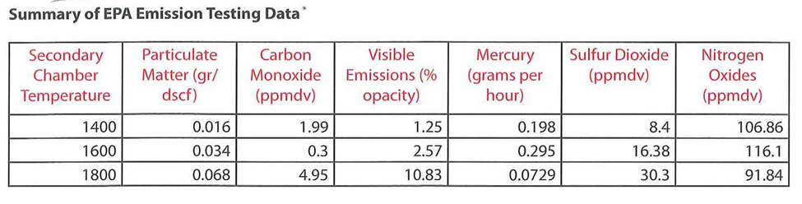
As cremation rates continue to increase in the United States, funeral homes without crematories are evaluating the prospects of constructing their own facility. While some homes are equipped with their own crematorium, those who do not are undoubtedly conducting environmental scans and market analysis for the plausibility of new construction. This will likely foster continued resistance among some community groups. In this context, the issue of air quality associated with crematories will be an ongoing controversy. We contend that the collection and analysis of crematory emissions warrants investigation.

Methods
Building Collection Apparatus
A collection apparatus was constructed with ½ inch inside diameter (ID) iron pipe that can be purchased at any hardware store. To construct the apparatus, five five-foot sections of pipe were used, including a 90° tee fitting, three connecting fittings, and one cap as shown in Figure 1. The top end was heated and angled to a 35° bend. This would assure sufficient exposure to the emissions. One section of the pipe was drilled and tapped to accommodate a commercially available K-type thermocouple capable of reaching 982.2 °C. In addition, the apparatus was equipped with a Max6675 integrated circuit (calibrated to boiling water--which does not exceed 100 °C). The thermocouple was attached to an Arduino Mega 2560 (Arduino) and in return, the Arduino was connected to a laptop for inline temperature reading throughout the sampling. The temperature code for the Arduino can be found in Figures 2 and 3.
The collection of organics was modeled from Harless et al. 1999, in which a polyurethane foam (PUF) plug was used to capture the organics. A 2.2 cm X 7.6 cm PUF plug manufactured by SUPELCO under the item number 20600-U was also utilized. With the reduction of cost in mind, glassware from the University of Central Oklahoma chemistry lab was used to construct an all-glass housing for the PUF plug using an open-mouth addition funnel, condenser, a 30 mL beaker, and glass tubing. Simple glass blowing techniques were used to heat and construct an enclosure allowing for the insertion and removal of the PUF plug.
Figure 1. The overall design of the iron collection apparatus showing the vacuum (V) and the Arduino Mega 2560 (A). The vacuum is attached to the glass PUF filter enclosure on the tee fitting.
Before sampling, ethanol was used to clean the pipes and glassware. Sample collection was performed using a pre-cleaned PUF plug. After collection, the plug was placed into a clean, air-tight brown glass bottle to avoid contamination.
Figure 2: Temperature probe code 1. The code used for the Arduino Mega 2560 and K-type thermocouple.

Figure 3: Temperature probe code 2. Additional code for the Arduino and K-type thermocouple.
Extraction of Organics
An Agilent 7890A Gas Chromatograph-Mass Spectrometer was used in conjunction with an Agilent 5975C quadrupole mass spectrometer with a triple axis detector was also used. An Agilent 30m x 0.25 mm x 0.50 µm HP-5ms non-polar capillary column was used for analysis.
The temperature program employed follows the settings outlined by Madellena et al. (1998). The front inlet was set at 285 °C; oven pressure at 15.69 psi; and the gas flow was set to 1.493 mL/min. Helium was used as the carrier gas. Samples were 1 µL, splitless injections. The initial oven temperature was set at 40 °C and held constant for five minutes. The temperature was then increased to 270 °C at 10 °C/min and held constant for five minutes; then increased to a final temperature of 310 °C at 10 °C/min, and held for four minutes. A 10-minutes solvent delay was added to program. The mass spectrometer detector (MSD) transfer line was set to 295 °C. The mass spectrometer (MS) source was 230 °C and MS quad was 150 °C.
Extraction was done on the same day as the sample collection. A 200-mL soxhlet extractor with a 500-mL round bottom flask was used for the extraction process; top joint: 45/50, bottom joint: 24/40. Avoiding direct contact with the filter, the PUF plug utilized in the sampling was placed into the extractor. Approximately 300-mL of lab-grade toluene was added to the flask. Then the apparatus was allowed to boil for a 24-hour period. Afterwards, the solvent containing the extracted sample was rotary evaporated to between 5 mL and 10 mL. One µL of the resultant sample was injected into the GC-MS.
A blank extraction was also performed with a new PUF plug. The same procedures were followed as described above, excluding the rotary evaporation.
A 2,3,7,8-tetrachlorodibenzo-p-dioxin (TCDD) in toluene was acquired as a standard. A one ppm sample solution of the TCDD in toluene was prepared. One µL of the solution was injected into a new, pre-cleaned PUF filter and placed into the soxhlet extractor. Approximately 300 mL of toluene was added to the flask and the apparatus was allowed to boil for a 24-hour period. Afterward, one µL of the resultant solution was injected into the GC; no rotary evaporation was performed.
Analysis and identification of the compounds was accomplished using a National Institute of Standards and Technology (NIST) mass spectra library.

Analysis and Discussion
The temperature of the gas exhaust was required for a collection apparatus to be made to ensure that the correct materials were used. The average temperature ranged from 405° C with a maximum of 502° C (data shown in figure 4). The collection apparatus was first constructed with an all sodium borosilicate glass tubing; weight was a consideration because of the distance and temperature in the collection process. Before using the glass apparatus, a test was conducted to determine if this configuration was a viable option. During the test, the long tube section shattered due to the thermal stress from the extreme temperature difference of the weather and the temperature of the stack.
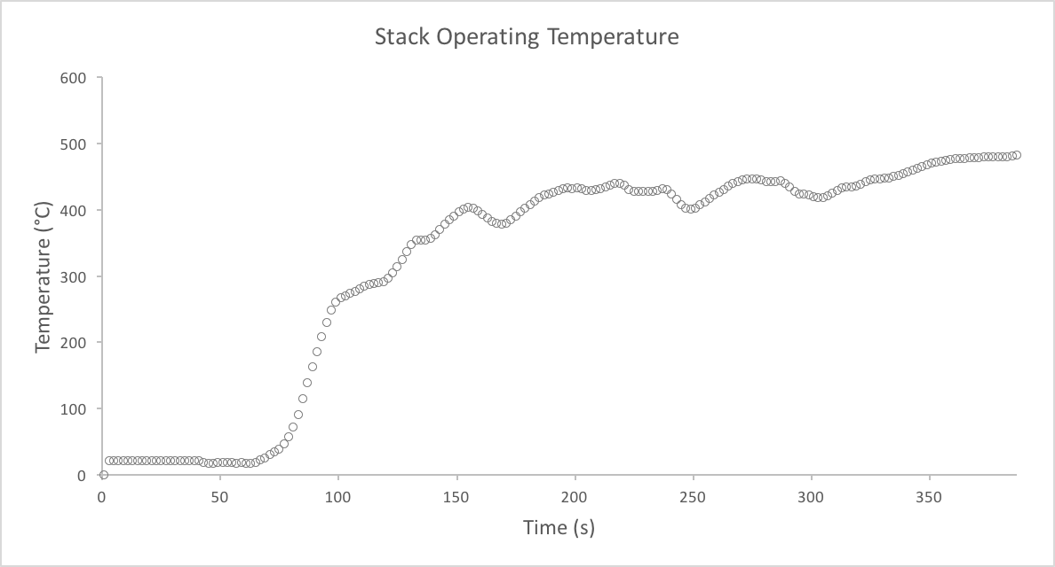
Figure 4: Stack Operating Temperature. The temperature that the crematory stack operates to be used for constructing a collection apparatus.

The iron apparatus was built in sections to be adjustable in order for the collection port to be moved up or down the apparatus based on weather (temperature) and for the ease of mobility. The close proximity of the collection port and temperature port was a precautionary measure to retain the integrity of the PUF filter.
The collection temperature of the sample (shown in Figure 5) manifested a low resolution. This made it difficult to determine a temperature at a point in time. A moving average (the red line in Figure 5) was determined calculated by a 10 data point average (at a time) for each data point. There were a few data points that existed between 1400 and 1500 seconds. We believe that this was instrumentation error due to the collection temperatures (i.e., never reaching below 8°C). In addition, temperature fluctuations were noted, most likely due to wind as well as the means in which the collection apparatus was stabilized (being held by hand), allowing for movement from hotter areas.
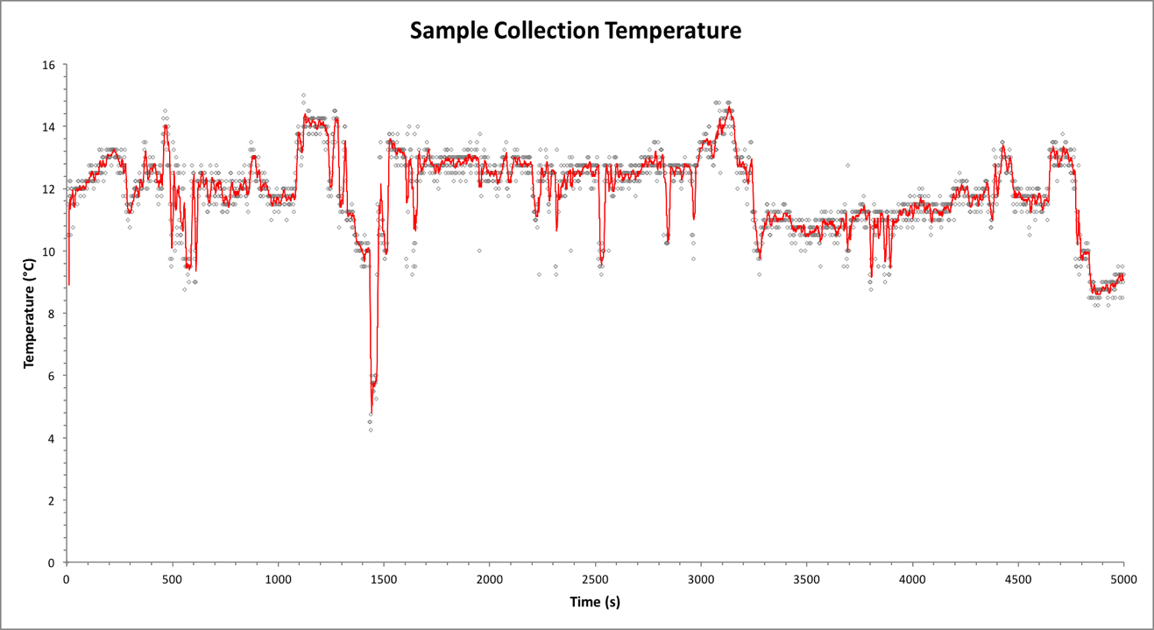
Figure 5: Sample Collection Temperature. A temperature of the collection port over 5000 seconds with a moving average of ten data point per moving average data point for clarity of the collection temperature at a given time.

Table 1 lists the compounds detected from the sample extracted from PUF filter. These compounds were determined solely by mass spectra library matches. Therefore, identifications are tentative until a more in-depth analysis can be performed. Spectra matches below a match quality of 50 were excluded from the results and table. The spectra were matched by the computer software by comparing the mass peak heights of the compounds detected to the mass spectra contained in the NIST library. Therefore, the higher the match quality, the greater the probability that matched compound is the true identity.
Preliminary results indicate the presence of numerous compounds containing aromatic rings, with one containing halogens. Several compounds containing alkene moieties were found to be present, along with compounds containing ester moieties and nitrogens. Also note, that many of the compounds contain multiple benzene rings or diphenyl structures. Figure 6 displays the chromatogram of the exhaust sample collected and extracted from the PUF filter. The three largest and most distinct peaks at 11.396, 12.628, and 19.905 minutes were identified as being benzaldehyde, benzyl alcohol, and 1,1'-(1,2-ethanediyl) bis-benzene.
For analysis, integration was performed via a computer program, which involves the calculation of the area under each peak. From the integrated results, these three peaks combine to make up approximately 73.7% of the total area, making up the majority of the compounds collected. Of greater interest is the 1-chloro-3-methyl-benzene peak at 12.243 minutes, since the polychlorinated dibenzodioxins (PCDDs) were the target molecules for this study. The presence of a chlorinated aromatic ring shows that the basic building materials for PCDD, more specifically TCDD, were present. However, the TCDD was found to elute around 28.6 minutes via a standard solution of TCDD; no peak appears at that time in Figure 6. Although no PCDDs were detected in this sample, an absence in a peak could simply indicate that the level of PCDDs were too low to be detected. The volume of gas pulled through the sampling apparatus would affect this to some degree, since the concentration of a component would be directly related to the volume.
Most notable of the compounds detected was 4β,10α-dihydro-benzo[β]benzo[3,4]cyclobuta [1,2-e][1,4]dioxin at 23.966 minutes. Although larger in size than the desired compound, TCDD, this identified compound contains a key benzodioxin structure with two oxygens attached ortho with respect to each other on a benzene ring and those two oxygens are connected to the rest of the molecule. The presence of a dioxin structure also lends credence to possibility to the formation of TCDD during the combustion process.
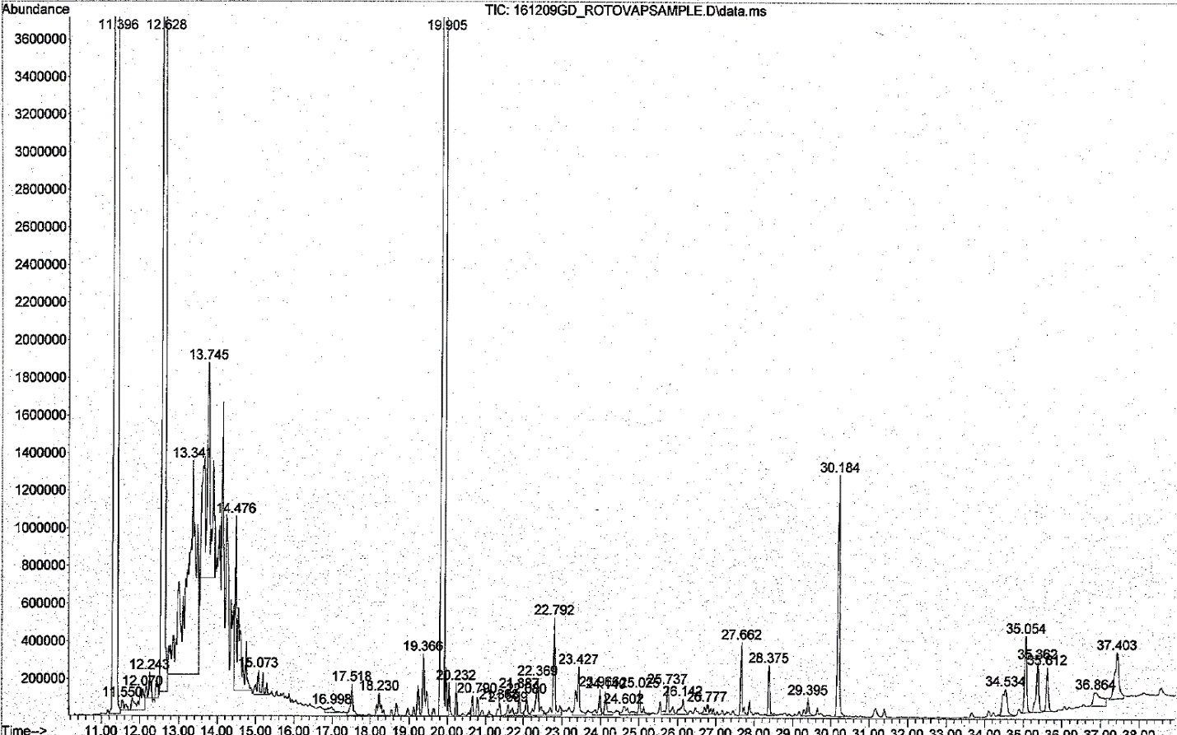
Figure 6: Chromatogram of sample. A total ion count (TIC) of the compounds collected from the crematorium exhaust drawn through a PUF filter and extracted over a 24-hour period in toluene.

RT | Area% | Identified compound | Match quality
11.3965 | 27.0667 | Benzaldehyde | 95
12.0702 | 0.49 | Hexylcyclopentane | 52
12.2434 | 0.3075 | 1-chloro-3-methyl-benzene | 60
12.6284 | 16.4106 | Benzyl Alcohol | 97
13.3407 | 8.0281 | (E)- 2,2-dimethyl-3-Decene | 64
13.7449 | 4.0683 | (E)-3-Dodecene | 64
17.5178 | 0.2623 | 2,4-diisocyanato-1-methyl-benzene | 98
18.23 | 0.2346 | Diphenylmethane | 96
19.9047 | 30.2098 | 1,1'-(1,2-ethanediyl)bis-benzene | 93
20.232 | 0.1535 | 1,1'-(1-methyl-1,2-ethanediyl)bis-benzene | 94
20.7902 | 0.2431 | 3,4'-dimethyl-1,1'-biphenyl | 98
21.3677 | 0.1213 | 1,1'-[oxybis(methylene)]bis-benzene | 64
21.5987 | 0.1452 | Oxalic acid, monoamide, N-(2-phenylethyl)-, isohexyl ester | 72
21.8874 | 0.1768 | (2-methylphenyl)phenyl-methanone | 64
22.0799 | 0.1401 | (E)-Stilbene | 98
22.7922 | 0.7186 | 4-(2-phenylethenyl)-(E)-phenol | 64
23.4274 | 0.4849 | 2-Amino-5-isopropyl-8-methyl-1-azulenecarbonitrile | 87
23.9664 | 0.2032 | 4β,10α-dihydro-benzo[β]benzo[3,4]cyclobuta[1,2-e][1,4]dioxin | 87
24.1396 | 0.2009 | 2-(diethylamino)-N-(2,6-dimethylphenyl)-acetamide | 64
24.6016 | 0.1883 | E-8-methyl-9-tetradecen-1-ol acetate | 56
25.7373 | 0.2886 | 3-methyl-1,5-diphenyl-2-pyrazoline | 58
26.1416 | 0.1885 | 4-[[(4-methoxyphenyl)methylene]amino]-benzonitrile, | 76
26.7768 | 0.154 | 1-methylsulfonyl-1,2-diphenylethane | 72
29.3947 | 0.1727 | 3,3'-dimethylbiphenyl | 70
30.184 | 1.5751 | 1,2-Benzenedicarboxylic acid, diisooctyl ester | 64
35.0541 | 0.5653 | (3β,17E)-Pregna-5,17(20)-dien-3-ol | 78
Table 1: Matched compounds from sample extracted from the PUF filter. Mass spectra matched identifications of the compounds extracted from the PUF filter. This was done with a 1µL splitless injection.

Limitations and Future Research
The primary limitation of this study resides with the small sample size coupled with the complications of the design and construction of the instruments to conduct both the collection and analysis of emissions. While we were successful in identifying crematory emissions (i.s., dioxin-like molecules) the small sample size and the limitations of the instruments, inhibited the count or concentration of these particles. An additional and disappointing limitation of this study was the fact that the method for analyzing mercury was not fully developed at the time of the analysis of the emissions, and therefore we were unable to test for mercury. Future projects will need to resolve these issues before we can generalize any health and environmental concerns surrounding crematory emissions.

References
Cremation Association of North America. (2014). Annual CANA Statistics Report: Featuring final 2012 data. Newly released 2013 data, and projections to 2018. Minneapolis, MN
Cremation Association of North America. (2014.) The CANA Crematory Operation Certification Program Manual (2nd ed.) Wheeling, IL
Fleege, A. (2005). Dr. Francis Julius LeMoyne: Origins of cremation in the United States.
Journal of Funeral Service Education, 11, (1), 46-57.

Fritch, J.B., & Altieri, J.C. (2015). Fires of change: A comprehensive examination of
cremation, Oklahoma City, OK: Funeral Service Education Resource Center.
National Funeral Directors Association, (2014). Cremation standards for funeral service
professionals, Brookfield, WI: National Funeral Directors Association of the United States,
Inc.

Prothero, S. (2001). Purified by fire: A history of cremation in America, Berkeley, California:
University of California Press

Steward, G., Fritch, J.B., & Spomer, J.C. (2016) Standing room only: The contentious
crematory debate in the sleepy town of Bethany, OK. Journal of Funeral Service
Education, 16 (1), 4-30.
Steward, G., & Fritch, J.B. (2017) The crematory debate: Key framing processes. Journal
Of Funeral Service Education, 17 (1), 4-35.

Emotional Intelligence Ability as a Possible Motivating
Characteristic of First-Generation Mortuary Science Students

Cody L. Lopasky and Rick Harrington
University of Houston – Victoria

Author Note

Cody L. Lopasky, Social and Behavioral Sciences, University of Houston-Victoria; Rick Harrington, Social and Behavioral Sciences, University of Houston-Victoria.

Cody L. Lopasky is now Associate Dean of Academics, Commonwealth Institute of Funeral Service.

This research was conducted by Cody L. Lopasky in fulfillment of his thesis for a Master’s degree in Interdisciplinary Studies at the University of Houston-Victoria.

Correspondence concerning this article should be addressed to Cody L. Lopasky, Associate Dean of Academics, Commonwealth Institute of Funeral Service, 415 Barren Springs Dr., Houston, TX 77090. Email: c.lopasky@commonwealth.edu

Abstract
The funeral profession in the United States, once almost the sole purview of family businesses, initially lagged the general trend toward business corporatization. However, this trend began to change in the latter half of the twentieth century. Since that time, familial ties that once brought people into the business became less dominant in the industry as evidenced by the growth of limited liability corporations (LLCs) and publicly traded corporations. This prompts the question, outside of family ties, what today motivates those who seek the funeral profession? The present study hypothesized that higher levels of emotional intelligence ability may be a common motivational characteristic of first-generation funeral directors. This ability is defined as the capacity to properly identify the emotions of others and manage one’s own emotions accordingly. An experimental group of first-generation mortuary school students was compared to a control group of university students to determine if the mortuary students had higher levels of emotional intelligence. Contrary to expectations, results did not support the hypothesis. Suggestions for future research are discussed.

Introduction
Historical records indicate that the funeral business in the United States was an outgrowth of the American Civil War. Unparalleled numbers of military deaths occurred on distant battlefields far away from soldiers’ homes. This was especially true for Union soldiers because most land campaigns were conducted on Confederate soil. New technology and advances in the process of embalming allowed, for the first time, soldiers to be shipped home and viewed in a preserved and natural state before interment. Famously, Dr. Thomas Holmes embalmed roughly 4,000 soldiers by war’s end (Grant, 2004). Embalming next received a boost in popularity with the assassination of Abraham Lincoln. His embalmed body, viewed by untold numbers, publicly exhibited the benefits embalming. This established a desire by the public for embalming of their own loved ones, and in turn, a need for professionals to perform this process. And so, the American funeral industry was born.
Early on, the business of undertaking was assumed by already-established tradesmen like furniture makers. Societal forces slowly created a greater demand for funerary professionals to remove the aspects of death from the family. Furthermore, a place for preparation and ceremony outside of the home eventually became standard, and businesses tending to the dead increasingly became single-purpose. Thus, funeral homes and funeral parlors were created. These businesses were most often family-owned and continually operated by successive generations. Children and/or relatives of the funeral home owner would learn the trade and eventually take over the business. Laderman (2007, p. 6) discussed the view in the industry that the next generation would continue the “undertaking work performed by their fathers and grandfathers.” This model of self-proprietorship was altered in the 1960’s by the establishment of Service Corporation International or SCI; the first publicly traded death care company (Barrett, 2013).
With the growth of SCI, Carriage, and other funeral companies both large and small, the family connections that once opened the door to a career in funeral service began to erode. The once-obvious reason for the career path was disappearing. According to a statistic from the National Funeral Directors Association, 14% of American funeral homes were corporately owned in 2013 as compared to only 1% in 1971 (Pine, 1975). Though not a majority, the presence of corporatized death care often skews much higher in certain urban markets. In all, family-owned firms are numerically decreasing. So why do the 33,000 American funeral directors choose a career in the funeral industry (NFDA, 2013)?
This study sought to answer that question by positing a psychological characteristic that could potentially be more common among those in this career field. Like those in any specialized industry, funeral directors must have certain skill sets; some emotional. Each day, funeral service professionals are placed directly in the path of emotionally charged and often intense situations simply by going to work. Based on this occupational condition, it may be that higher emotional intelligence is the common thread that draws non-familial persons to the funeral profession.
Emotional intelligence is a psychological concept that is divided into two distinct subfields; trait and ability. The trait construct defines emotional intelligence as a heritable personality trait; whereas ability emotional intelligence is described as a cognitive ability likened to other measured intelligences (Austin, 2010). The focus of the present study is ability emotional intelligence. Ability emotional intelligence is loosely defined as the ability to monitor one’s own emotions and those of others, and then guide one’s actions and emotions accordingly (Salovey & Grewal, 2005). Successful funeral directors must do this daily.
Abundant research has focused on emotional intelligence in the workplace. For example, Moon and Hur (2011) explored the connection between job performance and emotional exhaustion. They discovered that emotionally intelligent employees cope better with occupational stress. Additionally, emotional intelligence and empathy appear to be linked within an occupational setting (Martos, Lopez-Zafra, Pulido-Martos, & Augusto, 2013). Given the importance of empathy and emotional sensitivity to the success of funeral professionals, it stands to reason that emotional intelligence would also be an important characteristic within this profession. Unfortunately, literature reviews reveal a paucity of research in this area.
Most evidence-based funerary research concentrates on those that are served by the industry and not those who operate within it. For example, Riordan and Allen (1989) discussed grief counseling in a funeral home setting. Few studies focus on funeral directors themselves, and the few that do, examine the psychological toll associated with working around death. Linley and Joseph (2005) explored occupational death exposure and discovered that positive personality changes are possible. Ward, Flisher, and Kepe (2006) examined mental health consequences associated with mortuary work and found stress intervention to be beneficial. Closer to this study’s topic was the work of Richard Lonetto (1982) who utilized mortuary science students as a group to study death anxiety. He discovered a relationship between personification of death and death anxiety. Perhaps the best supporting research came from Spencer Cahill (1999) who explored the reasons for mortuary science student success as they actively participated in an accredited mortuary science program. Observation was employed over a five-month period to examine the peculiar professional socialization of mortuary science students; specifically, the normalization of working with the dead. Cahill’s strongest indicator of success was what he termed emotional capital. Unfortunately, he did not collect any quantitative data to support his hypothesis. It is notable, though, that Cahill’s article echoes this study’s assertion that other emotionally-charged professions (e.g., physicians) receive much more scholastic attention than do funeral directors.
Many theories abound as to why those not connected to the industry elect to receive a mortuary science education and become funeral directors. Some say their career choice stems from either a positive or negative experience with a funeral or funeral director. This study examined one possible motivator by hypothesizing that first-generation mortuary science students would have a significantly higher level of emotional intelligence than a control group.
Method
Participants
To conduct the research, two separate groups were surveyed. One group represented those entering a career in funeral service, and the other group was similar in nature but not connected to the funeral industry. Therefore, the experimental group consisted of mortuary science students, and the control group contained only undergraduate university students.
The mortuary students in the experimental group were recruited from two separate accredited mortuary science programs; each located in Texas. A total of 65 mortuary science students volunteered as participants in the study. They ranged in age from 18 to 55. The mean age of the group was 26.62. There were 49 females, 15 males, and one participant that declined to specify a gender. Forty-seven of the volunteers came from Texas with a few being from other US states and other countries. Of these, 11 participants had a family connection to the funeral industry, and their data were not included in the primary analysis because they lacked the first-generation characteristic that was sought for this group.
The control group was formed by undergraduate students from a regional university in Texas. This group had 94 participants with 62 females and 32 males. Their age range was 18 to 52 with a mean age of 21.86. Like the experimental group, most of the participants, 80, came from Texas with a few others from different states or countries. In general, the collected demographics were similar between the two groups.
Procedures
All participants were surveyed using two different emotional intelligence ability tests and a brief demographic questionnaire. Permission was obtained from all applicable persons and/or institutional review boards, and then individual instructors granted access to their face-to-face classes to recruit student volunteers. All student volunteers gave written consent. American Psychological Association standards for ethical research were strictly followed.
After collecting the data, the demographic form was used to identify and remove those participants that were in some way family related to a funeral service practitioner. This was done because their familial relationship to the profession disqualified them from being considered first-generation. First generation participants would not be drawn to the profession because of family, and thus family could be ruled out as a confounding variable when testing for differences in emotional intelligence. After adjusting for those participants with a family connection, the sample size for the experimental group was n = 54, and the size of the control group was n = 94.
Measures
In total, three different self-report instruments were used. The first of the three was created for the purposes of the study, and it was an eleven-item demographic questionnaire. It contained the study’s central question which asked whether a participant had any relationship to a funeral director, embalmer, undertaker, mortician, or funeral service professional. Because these terms are largely synonymous and can be interchanged, they were all included on the referenced question. Doing this allowed for more accurate responses regardless of a participant’s terminological preferences.
The other two instruments measured features of emotional intelligence ability. These were the Situational Test of Emotion Management – Brief (STEM-B) and the Situational Test of Emotional Understanding (STEU). Validity, a lack of time constraints, and availability all contributed to the decision to use these instruments. Based upon situational judgement tests, the STEM and STEU were originally created by MacCann and Roberts (2008). These tests were designed as less time-consuming and more cost-effective alternatives to the Mayer-Salovey-Caruso Emotional Intelligence Test (MSCEIT) which had long been the standard for ability emotional intelligence testing. Ferguson and Austin (2011) provided validation for the total scale scores of the STEM and STEU. Like the MSCEIT, scores of the STEM and STEU were found to correlate positively with intelligence tests. Usage of the situational judgment test format for the STEM and STEU was supported by research from Libbrecht and Lievens (2012) who confirmed that the format itself was apt for tests of emotion management and understanding. A newer abridged version of the STEM was created, the Situational Test of Emotion Management – Brief or STEM-B, and found to be as equally valid as the original STEM (Allen et al., 2015). The STEM-B and STEU, the two self-report instruments used in the present study, both utilize scenario type questions. The former consists of 18 test items and the latter 42.

Results
Data analysis and simple comparison showed that the difference in mean scores between the two tested groups was non-significant. The composite mean scores for the experimental group and the control group were 33.56 and 33.68, respectively.
Specifically, a 2 X 2 ANOVA with male vs. female (to rule out any gender effects) by control group vs. experimental group was run using only the experimental group participants that lacked a familial connection. Next, a second 2 X 2 ANOVA was conducted that tested male vs. female by the control group vs. the entirety of the experimental group.
The results of the mortuary students versus the university students for the first ANOVA were F (1, 143) = .02 (n.s.). The second ANOVA’s between group results were F (2, 152) = .071 (n.s.). Additionally, the ANOVAs’ results showed that the main effect for gender was not significant; ruling out any potential gender differences.
Discussion
This study did not support the hypothesis that ability emotional intelligence was higher among first-generation mortuary science students without a family connection to the funeral business than the levels found in general university students. It may be that the study failed to detect differences because differences do not exist. Alternatively, it may be that differences do exist and can be detected with greater statistical power, different populations within the funeral industry, or with a focus on trait rather than ability emotional intelligence.
The historical connections that once made the funeral service an obvious career option have, for the most part, disintegrated. For those numerically few that still have a familial connection to the industry, there is little mystery surrounding the career path. However, for most practitioners that lack a funerary family connection, the question remains: Why become a funeral director? As noted previously, the research on industry professionals generally concerns the mental health aspects of the job, but very little has been done to ascertain the personality traits or characteristics that may have a correlation with a career in the funeral business. Future research has many starting points from the current study. Finding the personality aspects (especially those of an emotional nature) that are germane to the funeral industry could have positive and practical applications.
This study had several limitations which should be addressed in future research. Perhaps the collected sample sizes were simply too small. Larger samples would have more power to detect small differences. However, increased power would seem unlikely to have detected differences since there were no near-significant findings in the present study.
Maybe the use of students and not full-time funeral professionals affected the results. Emotional intelligence may grow with experience in the funeral industry. Additionally, surveying funeral directors that have been active for a few years will correct for mortuary school dropouts and those that leave the profession early in the career. This limitation is important because only 50% of mortuary school graduates are working in the industry just five years after graduation and licensure (Klicker, 2008). It is possible then that those who do not have the requisite levels of emotional intelligence self-select out of the profession. If so, then those who remain in the profession would likely have higher levels of emotional intelligence.
Another possible avenue for further research could be the emotional intelligence differences between embalmers and funeral directors. These two jobs can be performed by the same person or two separate people depending on their level/type of licensure and the operating style of the funeral home. An embalmer generally works more in the preparation room and less with the grieving families. On the other hand, funeral directors tend to have more face-to-face interactions with the families of the deceased. Future research could delve into this split within the industry to see if the two differing sides of the career are reflected in emotional intelligence.
In choosing the ability construct for this study, the trait model was not explored. After failing to support a hypothesis with ability emotional intelligence, perhaps the trait model should be examined. If it were discovered that a certain, inherent personality trait predisposed a person to better handle the emotional aspects of a funeral service career, then perhaps the issues of burnout, emotional exhaustion, and turnover could be dealt with effectively. These problems have long plagued the industry. As noted by Klicker (2008), funeral homes devote a quarter of their revenue to personnel. Therefore, finding the right people for the job and then keeping them is paramount to successful business practices.
Are the characteristics of a good funeral director fluid or crystalized? If in fact the requisite aspects are static traits, then perhaps some people are simply born to be a better funeral professional, and specially-designed personality instruments could prove beneficial for hiring. On the other hand, discovering that the emotionally specific facets of the funeral director are fluid would open other doors. If the necessary abilities and characteristics are malleable across time, then employee training programs could be designed to help businesses strengthen those attributes of the workforce. For mortuary science curricula, courses and lessons could be instituted that foster the emotional abilities of new funeral service practitioners.

References
Allen, V., Rahman, N., Weissman, A., MacCann, C., Lewis, C., & Roberts, R. D. (2015). The Situational Test of Emotion Management – Brief (STEM-B): Development and validation using item response theory and latent class analysis. Personality and Individual Differences, 81, 195-200. doi: 10.1016/j.paid.2015.01.053
Austin, E. J. (2010). Measurement of ability emotional intelligence: Results for two new tests. British Journal of Psychology, 101, 563-578.
Barrett, P. M. (2013, October 28 – November 3). Mega death. Bloomberg Businessweek, 72-77.
Cahill, S. E. (1999). Emotional capital and professional socialization: The case of mortuary science students (and me). Social Psychology Quarterly, 62(2), 101-116.
Ferguson, F. J., & Austin, E. J. (2011). The factor structures of the STEM and the STEU. Personality and Individual Differences, 51(6), 791-794.
Grant, S. (2004). Patriot graves: American national identity and the Civil War dead. American Nineteenth Century History, 5(3), 74-100.
Klicker, R. L. (2008). Funeral directing and funeral service management. Buffalo, NY: Thanos Institute.
Laderman, G. (2003). Rest in peace: A cultural history of death and the funeral home in twentieth century America. New York: Oxford University Press.
Libbrecht, N., & Lievens, F. (2012). Validity evidence for the situation judgment test paradigm in emotional intelligence measurement. International Journal of Psychology, 47(6), 438-447.
Linley, P., & Joseph, S. (2005). Positive and negative changes following occupational death exposure. Journal of Traumatic Stress, 18(6), 751-758.
Lonetto, R. (1982). Personifications of death and death anxiety. Journal of Personality Assessment, 46(4), 404.
MacCann, C., & Roberts, R. D. (2008). New paradigms for assessing emotional intelligence: Theory and data. Emotion, 8(4), 540-551.
Martos, M. P. B., Lopez-Zafra, E., Pulido-Martos, M., & Augusto, J. M. (2013). Are emotional intelligent workers also more empathic? Scandinavian Journal of Psychology, 54(5), 407-414.
Moon, T. W., & Hur, W. (2011). Emotional intelligence, emotional exhaustion, and job performance. Social Behavior and Personality: An International Journal, 39(8), 1087-1096.
National Funeral Directors Association. (2013, April, 12). Trends and statistics. Retrieved March 14, 2014, from http://nfda.org/about-funeral-service-/trends-and-statistics.html
Pine, V. (1975). Caretaker of the dead: The American funeral director. New York: Irvington Publishers.
Riordan, R. J., & Allen, L. (1989). Grief counseling: A funeral home-based model. Journal of Counseling & Development, 67(7), 424.
Salovey, P., & Grewal, D. (2005). The science of emotional intelligence. Current directions in psychological science, 14(6), 281-285.
Ward, C. L., Flisher, A. J., & Kepe, L. (2006). A pilot study of an intervention to prevent negative mental health consequences of forensic mortuary work. Journal of Traumatic Stress, 19(1), 159-163.

Co-Editors:
Anthony Fleege, MBA
Southern Illinois University Carbondale
Mortuary Science and Funeral Service
Mailcode 6615
Carbondale, IL 62901-6615
(618) 453-5698
E-mail: splash@siu.edu

John B. Fritch, Ph.D.
Funeral Service Department
Coyner Health Sciences Building, 156
University of Central Oklahoma
Edmond, Oklahoma 73034
Ph. (405) 974-5195
Fax. (405) 974-3848
jfritch@uco.edu

Editorial Board:

Kevin Patterson, M.S.
Program Director
Des Moines Area Community College
Email: Kepatterson@dmacc.edu

Francisco E. Solis, Director of Education
San Antonio College
Mortuary Science Program
Email: fsolis@alamo.edu

David Hess, M.S. Ed.
Program Director
Salt Lake Community College
Division of Allied Health
David.Hess@slcc.edu

David Penepent
Program Director
SUNY Canton-Funeral Service Program
penepentd@canton.edu

